22.2
How are things in the kitchen?
Fine. Without Danielle, Sofi need help in the kitchen
That why I have 3 temp cooks in that with her
Temp cooks? Not real cooks?
Real cooks are expensive
OK
Where are they from?
The Blum agency, it’s a temp agency. They cheap… What is that?
Nothing, I can go to see. No problem in here, everything fine

Is this OK?
No, You must cut the meat into small pieces
Why?
You must cut the meat into small pieces because we need small pieces of meat for the recipe. Excuse me, but I have to talk to the other temp cook

What are you doing?
I’m stirring the soup
With your hand? This is a restaurant, you must use a spoon to stir something
Why?
Because customers eat the soup. I have to make new soup
You don’t have to make new soup. I can make it
Do you know how to make the soup?
No
Must I do everything?

Are you OK?
My hand hurt
Yes, it does. You must put into the cold water _. Do you know you have to wear mitts when you take something hot, out to the oven?
No, but I know now

Stop, everyone must stop work now. Come here. We have to talk

Why does Sofi need help in the kitchen?
-> Danielle is not there
Why doesn’t Nadi user real cooks?
-> They are expensive
How does the third cook hurt his hand?
-> He burns it
Why does Sofi tell the cook to stop?
-> She wants to talk to them

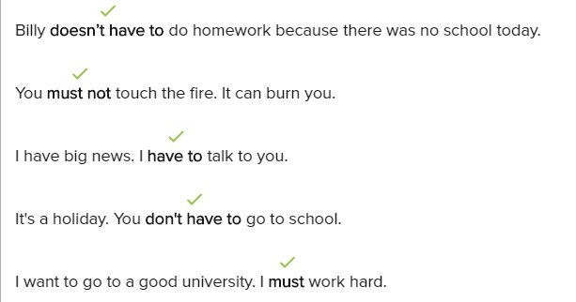

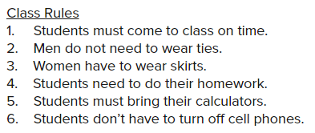
Students must arrive on time
Men don’t have wear ties
Women must wear skirts
Students have to do their home work
Students can use their calculators
Students don’t have to leave their call phones at home

Conversation

Please take the food out to the oven
Do I have to wear mitts?
Yes, you must to wear mitts
I have to get them from Diego
Use my mitts, Diego is busy
Thank you. Where do I have to put the food?
You have to put the put over there
Okay. Now I must cook the soup
You must use a spoon to stir the soup
Why do I have to use a spoon?
You must use the spoon, because customers eat the soup. Do you understand?
Yes, I must use the spoon, because customers eat the soup

Exercise
What must I do before I cook?
-> Wash your hands
He has to use the bathroom
-> It’s down the hallway
You must not stir the soup with your hand
If you don’t want any problems, you must listen to your teacher
You don’t have to cook because I am ordering pizza
Is the class hard?
-> No. It’s very easy. You don’t have to study

22.2.2
Tell me about yourself!
My name is Jim. I'm 24 years old. I'm single with no children. Is that good?
That's fine. Jim! what were your job before this job?
I was a taxi driver
Do you know how to work in the kitchen?
No. I don't how to cook

Tell me about yourself!
My name is Ted, I'm 36 years old. I'm married and I have 2 children
Interesting! Ted, what were your job before this job?
I was a _ officer
Do you know how to work in the kitchen?
No, my wife cook food for me. I don't know how to cook

What's about you?
My name is Cookie. I'm 28 years old. I'm single
What were your job before these?
I was a bussiness man
A bussiness man. Why are you here?
I'm a bad bussiness man
So, do you know how to work in the kitchen?
No, but I was all my meal from restaurant
What about you?
My name's Sofi. You know that. And I'm a cook at the restaurant. And I'm the only person here who know how to cook. I have to go now

I'm sorry Sofi
It's OK
Do you want to go outside?
Yes, please
How are you?
At the moment, I'm not good. Look in the kitchen
I know they cook and cook
No, they aren't. I don't know what to do. Last week was crazy. 3 days ago, Dannille was the head cook and it was good. Yesterday was Nadi and Dannille fire. And now Dannille isn't here. Right now, there are a lot to do, and I don't have a help I need
Those temp cook are here until Saturday. But we can get new help next week
Next week is far away
I know
A lot can happen in the week. Nadi can decide to fire me tomorrow. Today after, or next week. She is crazy. I don't want to work for her
I don't want to work for her, but I need the money to open my salon next year
You want to open salon next year
Yes, I want to work with hair and make up
Woa, good for you. Do you want to..Tell Nadi we need new help right now

What is true of all three temp cooks?
--> They don't know how to cook.

What is Sofi's problem?
--> She does not have the help she needs.

What does Diego want to do next year?
--> Start a business

When does Sofi need help?
--> Right now

